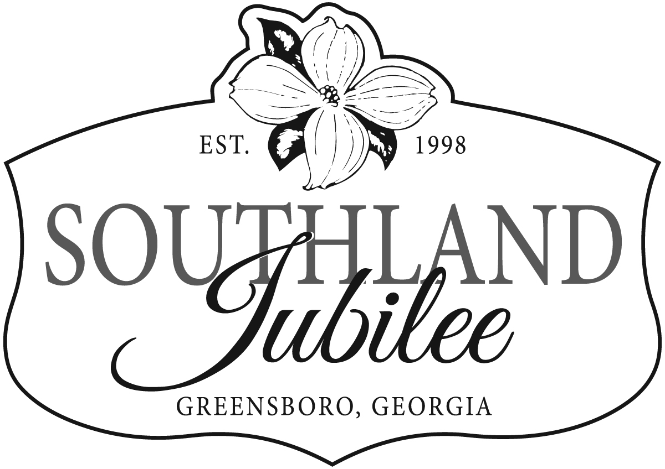

SOUTHLAND JUBILEE, APRIL 18, 2020
ARTS AND CRAFTS MARKET APPLICATION
Application Deadline: February 21, 2020

Business Name________________________________ Contact Person________________________________________

Mailing Address_________________________________ City/State/Zip_______________________________________

Phone #_______________________________________ Email_______________________________________________

Please select the category that best fits your handmade work:
 
___Leather  ___Metal   ___Glass  ___Photography  ___Fine Arts/Graphics

  ___Jewelry  ___ Pottery  ___ Textiles  ___ Wood  ___ Other

 Please fully describe your works and the products you will sell: ______________________________________________

_________________________________________________________________________________________________

Do you provide on-site demonstration of your art/craft? ____ Yes ___ No

If yes, please describe: _______________________________________________________________________________

__________________________________________________________________________________________________

I plan to set up my booth: ____ Friday evening, after 6:00 pm ____ Saturday morning, by 8:00 am

PAYMENT INFORMATION

_____ SPACES @ $50/space (early application mailed by 1/22/20) = ____________

_____ SPACES @ $70/space (application mailed 1/23/20– 2/21/20) = ____________

_____ ELECTRICITY @ $20/space = ____________

TOTAL FEE ENCLOSED $ ___________

Please make check payable to: Southland Jubilee 2020
Mailing address: P.O. Box 741 Greensboro, GA 30642

Application checklist: All of the following must be enclosed.

 ____ Completed application ____1 Photo of booth _____ 2 Photos of work   ____Fee

VENDOR AGREEMENT:
I do hereby release and forever discharge the 2020 Southland Jubilee Steering Committee and the City of Greensboro, its agents, servants, successors and assigns and all other persons, firms and corporations, from any and all actions, causes of actions, claims, demands, damages, costs, loss of service, expenses and compensations, which I may acquire or may accrue, arising out of any events taking place April 18, 2020 or otherwise connected with the 2020 Southland Jubilee Festival. I further certify that all work brought to Southland Jubilee is handcrafted by me, the undersigned.
I have read all Southland Jubilee rules and agree to abide by them.

Signature: _______________________________________________ Date: _______________________

